**TECHNICAL REFLECTION 1 EMERGING TOPICS IN ARTIFICIAL INTELLIGENCE**

**DreamBooth and Diffusion Models**

**Diffusion Models:**Diffusion models are a type of generative model that creates data, such as images, by reversing a process that gradually adds noise. In the forward process, Gaussian noise is incrementally added to an image until it becomes indistinguishable from pure noise. The reverse process, which the model learns, involves removing the noise step by step to reconstruct the original image. This allows the generation of new data by starting with random noise and iteratively denoising it to produce new, realistic images.One of the primary advantages of diffusion models over other generative models, like Generative Adversarial Networks (GANs), is their stability during training and the high quality of the generated samples. GANs often struggle with issues like mode collapse, where the model fails to generate a diverse range of samples. In contrast, diffusion models are less susceptible to these problems due to their robust probabilistic framework.

**DreamBooth:**DreamBooth is a technique developed by Google Research that allows for the generation of new images of a specific subject in various settings, styles, or poses based on a user-provided prompt. It works by fine-tuning a pre-trained diffusion model on a small set of images of the subject. This fine-tuning enables the model to generate new images that retain the subject's characteristics while placing them in different contexts or styles.

**My Experience with DreamBooth**

When I first encountered DreamBooth, it immediately reminded me of some apps that generate a perfect LinkedIn profile picture from a user's photo. I've seen these advertised on social media, and several friends have used them to create their profile pictures. However, since these apps typically require a subscription, I decided to see if I could achieve the same result by training the model on my own images.

The documentation suggests 800-1200 training steps for images containing faces, whtih a learning rate between 2e-06 and 1e-06, so I started with 800 steps, 2e-06 of learing rate and also included prior preservation.

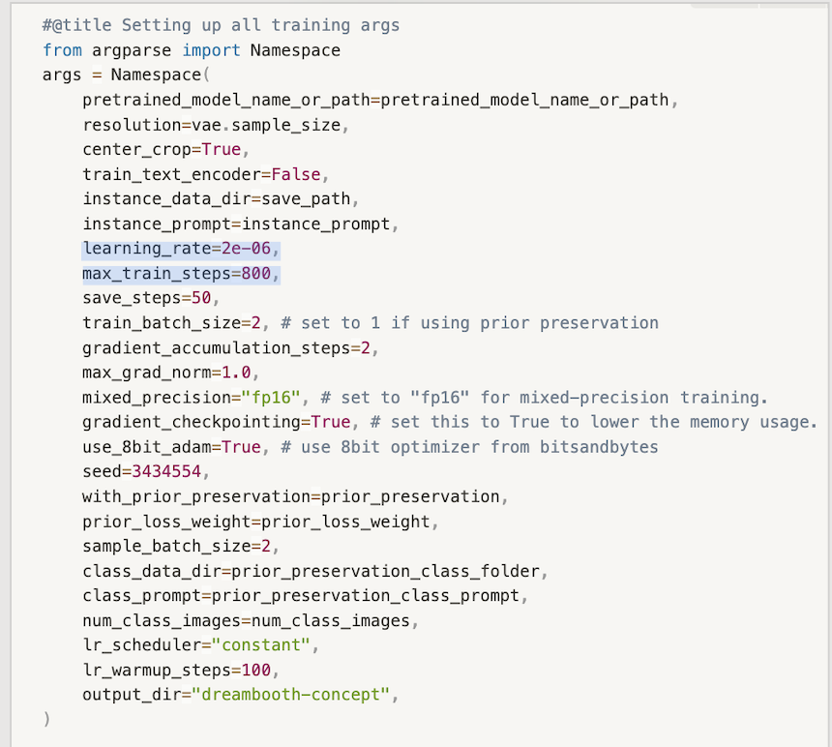

Since a small small batch size recommended, I uploaded two images ( the 2 on the left).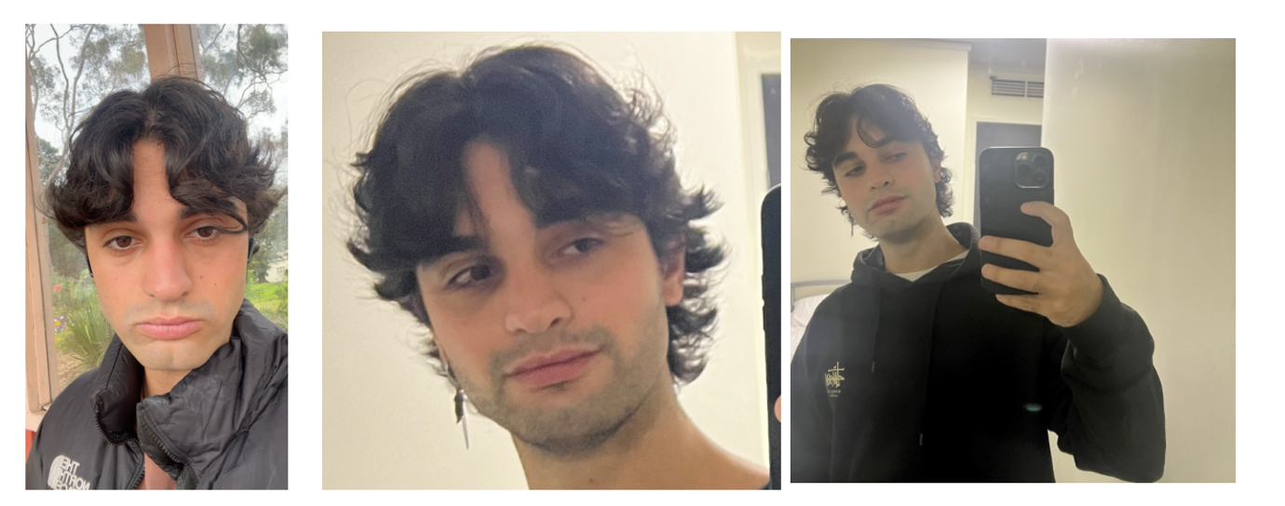

Initially, I encountered an error when trying to upload images directly from my device. To work around this, I first imported my images into my drive, made them publicly accessible via a link, and then generated the necessary links for both images.

The unique identifier I used for my subject was just ‘<Giovanni >man’ , my name. After patiently waiting for the model to train, I encountered an issue with the Hugging Face code to save the concept, but I wasn’t too concerned about it. I proceeded to generate two prompts: ‘Giovanni man wearing elegant clothes in an istitutional setting’ and ‘Giovanni man as a baby.’ Here’s the results: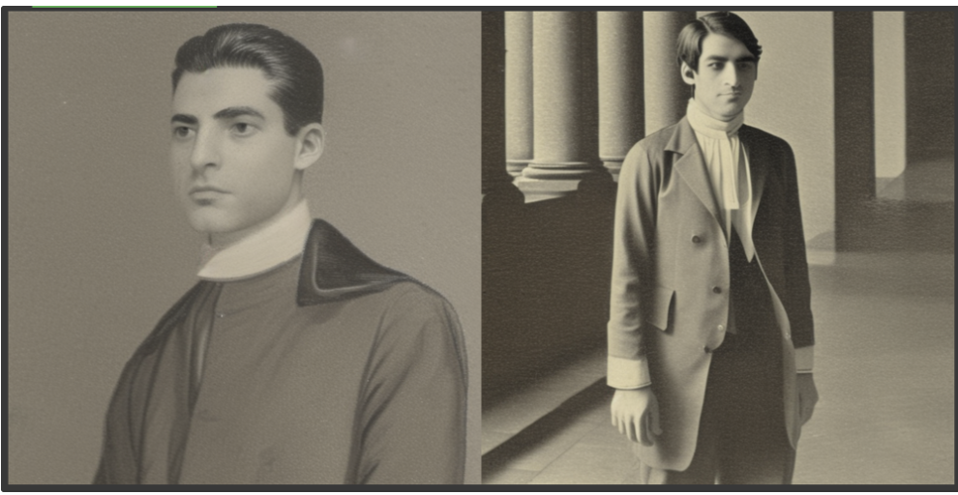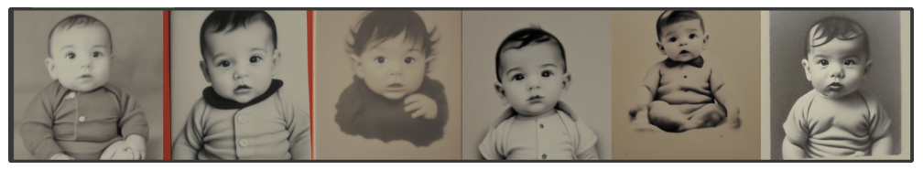

While I admit the second prompt wasn’t ideal, as it involved a significant modification of the subject (babies being quite different from an adult man), the results didn’t clearly reflect the model's capabilities. The elegant outfit and the institutional settings look quite outdated and the man in the image bore little resemblance to me—it could have been anyone. However, what stood out was that both prompts resulted in black-and-white images, which I hadn’t anticipated, given my training images were not.

I suspected that the model was underfitting, so I decided to increase the number of training steps and to add the third image in the training batch, though I didn’t save the concept at that stage.

**2 pictures 900 steps, 2e-06 learning rate**

During the initial training, I ran into computational limits, so I switched to my personal account and started the training process again. This time, I used the prompts ‘Giovanni in a park’ and ‘Giovanni as a cartoon.’ 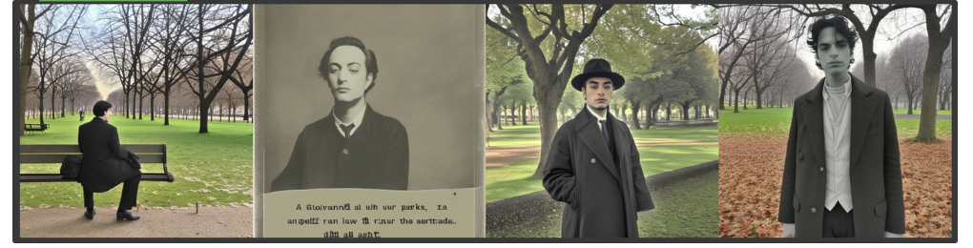

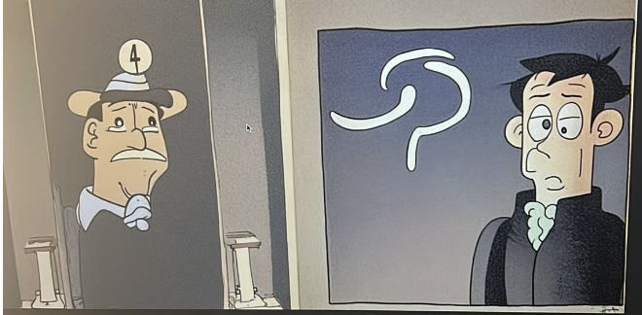

While some instances of the first prompt vaguely resembled me, the ones coming from the second prompt didn’t match at all. Once again, I was puzzled by the old-fashioned appearance of the generated images since neither my prompts nor the images I used had this characteristic. Additionally, I noticed that one the generated images included the name "Giovanni," which shouldn't have been present being it just supposed to be a meaningless identifier that the model should not learn (in terms of image reproduction)

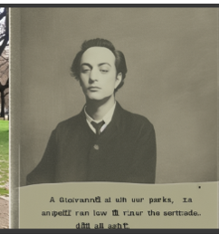

I decided to investigate what might have gone wrong. I found the answer in a YouTube video on training DreamBooth,thanks to which I learned that when training on human subjects, it’s advisable not to use real names. The model might associate the name with other instances of characters with that name, which is likely what happened in my case. "Giovanni" is a common Italian name with a long history, so the model may have drawn from other instances of "Giovanni." This also explained why the name "Giovanni" appeared in the generated images.

**3 pictures, 1000 steps, 2e-06 learning rate**

To address this, I trained the model again, further increasing the number of steps and using "<sks> man" as the identifier instead of my real name.

I encountered computational limits once again, and this time, I didn't have access to another Google account. Starting on Tuesday, the 21st, my SIM subscription had expired, which I only discovered a few days later. Without an active phone number, I couldn't create new Google accounts. I realized the issue on Friday 24 and tried to get a new subscription, but it was only activated the following Monday. Most of my experiments took place before I resolved this, so I had to wait a day each time to retrain the model.

The day after, I trained the model again and used the prompts ‘sks man in elegant clothes as a cartoon’ and ‘sks man wearing elegant clothes in an institutional setting.’

The model clearly overfitted during the latest training session. The generated images resembled the initial ones far too closely, as you can see.

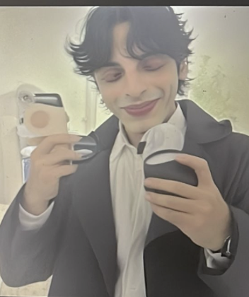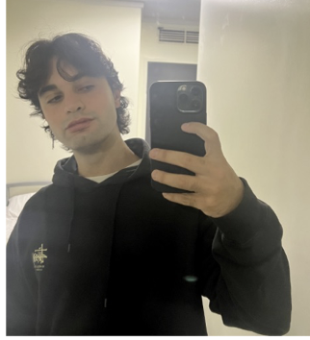

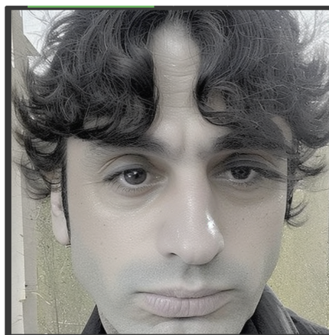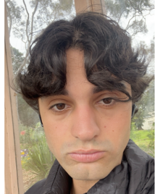

This indicates that the model didn't generalize well and instead became too focused on the specific details of the original images.

**1200 steps, 1e-06 learning rate**

Even if the model was already overfitting, just for curiosity I tried for 2 times to train increasing again the steps and reducing the learning rate even more, but I never managed to finish the train without the computing units running out.

**TASK 2**

The aim of task 2 was to fine-tune the model so that it would be able to learn two subjects and display them together in the same generated picture. First of all, I changed the variable **instance_prompt** from a string to a list.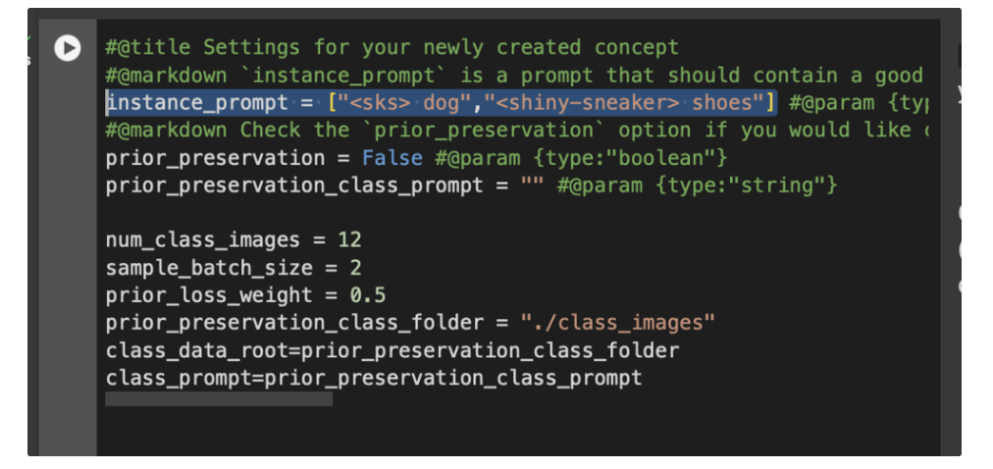

I inserted 5 URLs related to images of a dog and 5 related to images of a shiny shoe.

The provided URLs for the shoe were 6 but I chose to use the same number of images for each subject for better generalization when dealing with more than 2 subjects

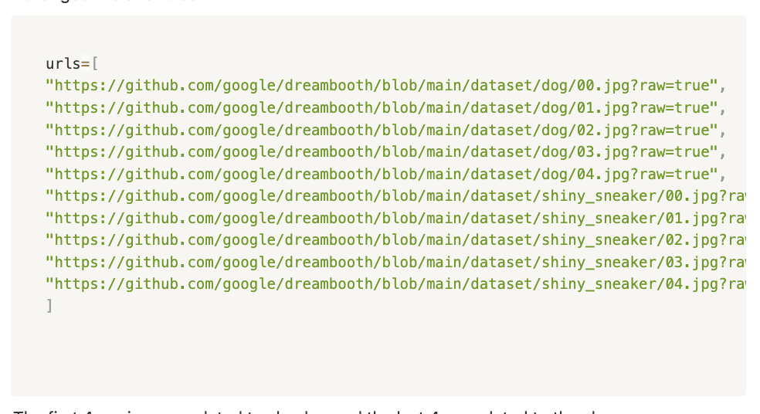

I realized that the key to achieving the desired outcome was to modify the **get_item** function so that each image would be correctly associated with its respective subject during training. Since the only argument in getitem is the index, this needed to be done using just the index. I came up with the formula

**index // (self._length // len(instance_prompt))**

which, given the index of the picture, effectively returns the index related to the correct subject in the **self.instance_prompt** list. This approach works as long as the number of pictures for each subject is the same.

If, however, we only want to model a case with different numbers of images per subject—like having 6 images for a shoe and a different number for another subject—then we could use an if condition such as one that would map the first 5 images to index 0 and the remaining ones to index 1.

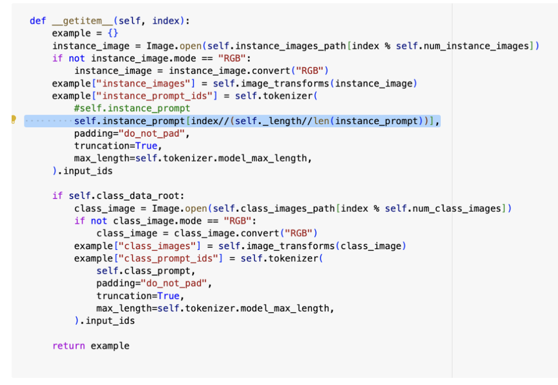

In the section related to saving the concept I modified the following line, changing the name of the concept from simply the instance prompt to ‘dogshoes’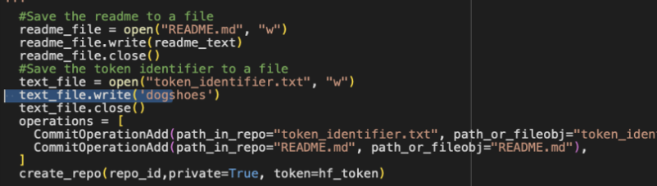

I trained the model and given the prompt ‘A sks dog and a shiny sneaker-shoe together on a grass’ and I got this result. 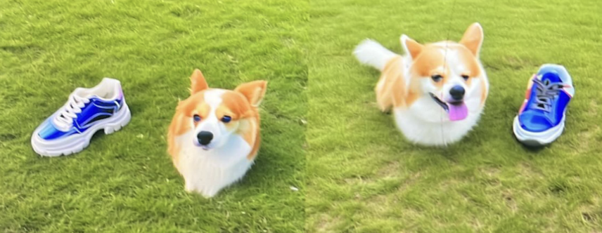

I also managed to save the concept adding the following lines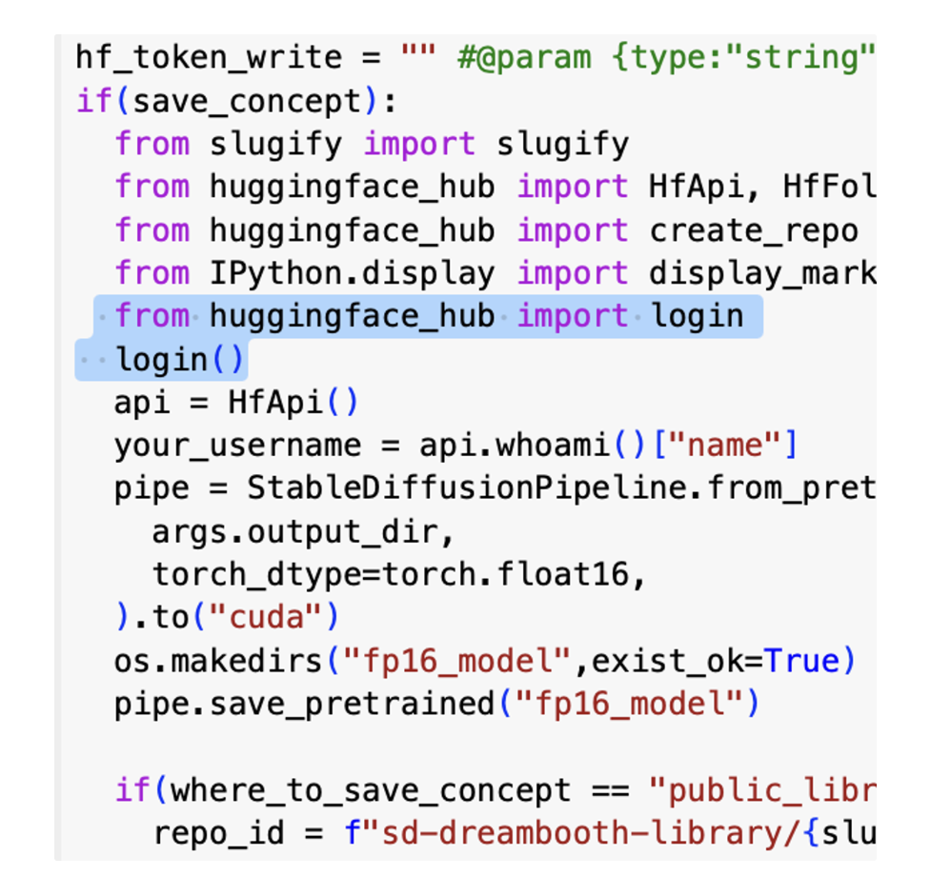

Then, before running the cell with the CLIP score, I tried to import the concept to see if tit worked using the lines of code suggested on hugging face: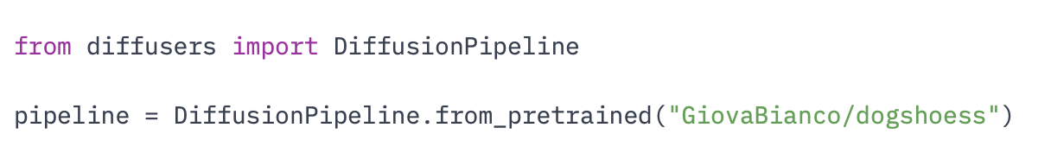

After training the model, the image generation initially took only a few minutes. However, once I imported the concept from hugging face, the generation process started taking as long as training the model all over again. Because of this, I figured it might be faster just to retrain the model. I did so, but unfortunately, this time the training produced worse results, as the generated images were not as expected.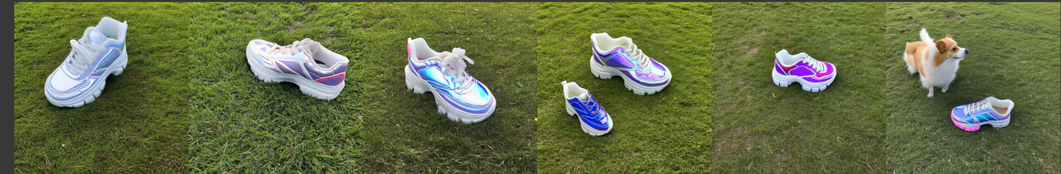

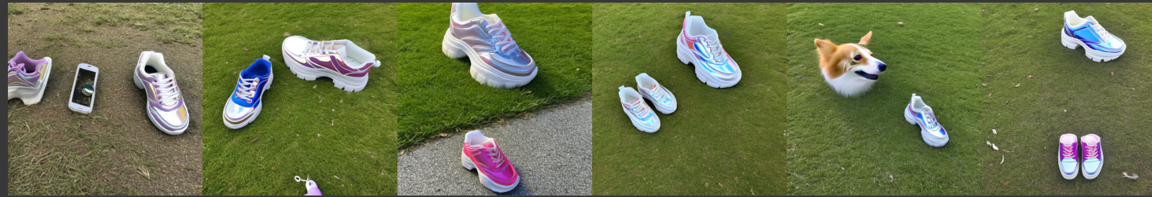

The model had probably overfit on the shoes this time, since only in few instances the dog was present inside the image. I tried to see if the problem involved the models not having learned the dog, so I tried to only generate instances of it. 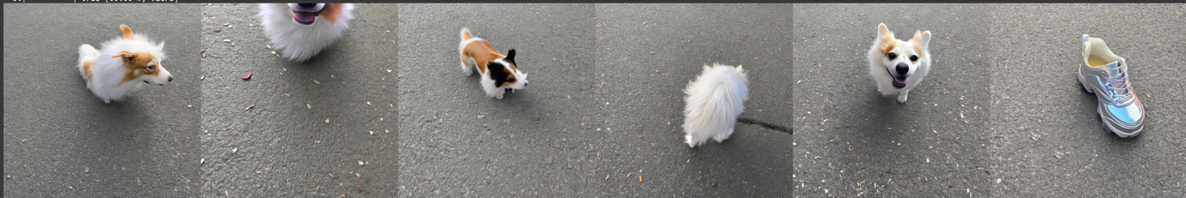

It turned out that the model had actually learned the subject (even tho in one of the 6 generated images it made a mistake), but the main issue was with combining the two subjects. When I attempted to calculate the CLIP score for the second model, the provided code threw an error, indicating that images, being a list, didn't have the method astype. To resolve this, I made some small adjustments to the code to account for this issue.

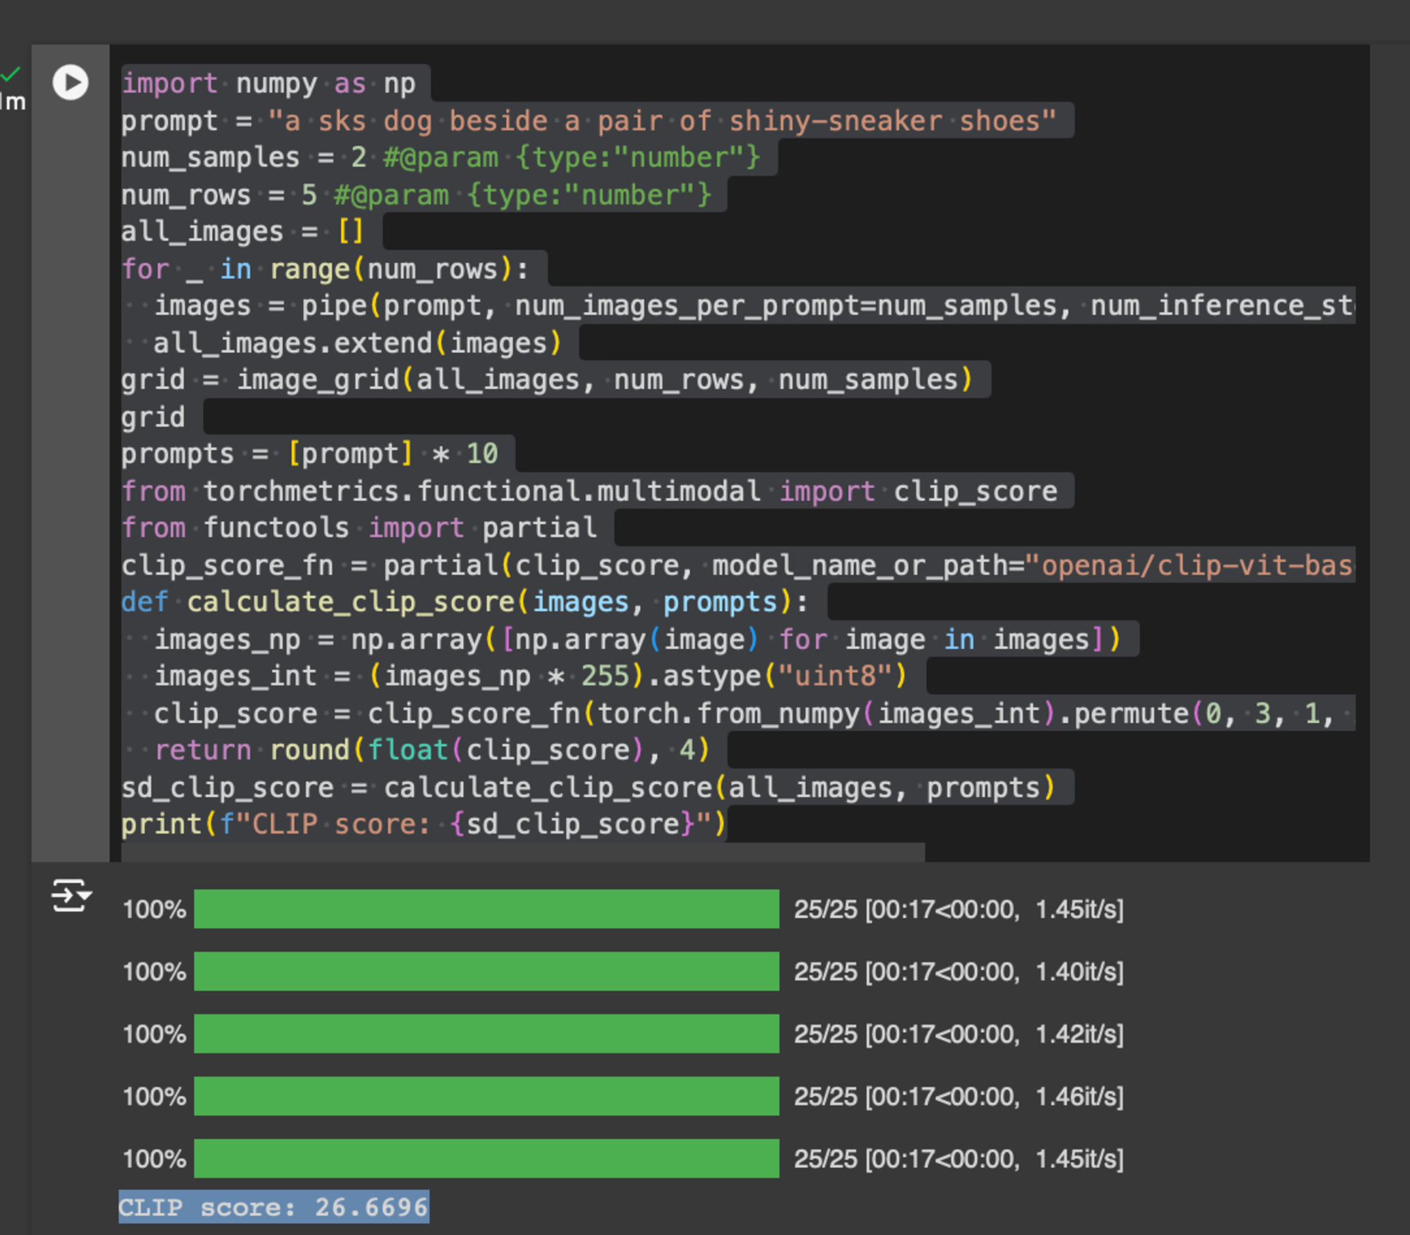

The CLIP score was 26.669.

I attempted to evaluate the CLIP score by using instances from the DreamBooth database, rather than user-generated ones. The CLIP score was around 32, which is quite far from the score achieved by my model. I suspect that increasing the number of training steps could improve the result, but unfortunately, I don't have enough time to retrain the model.

To conclude, I also managed to speed up the image generation with the model imported from hugging face adding modifying the code in the following way:



I therefore calculated the CLIP score on the first model and it was ,as expected form the results, higher than the second one.

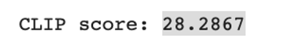

Both models were trained using the same parameters, and the differences in their results highlight the inherent stochasticity present in the training process.

.